# **Historical Events: Tibet**

# **Name:**

*Instructions:* Read the event(s) assigned to your group and answer the questions that follow. Be prepared to share your answers with the class.

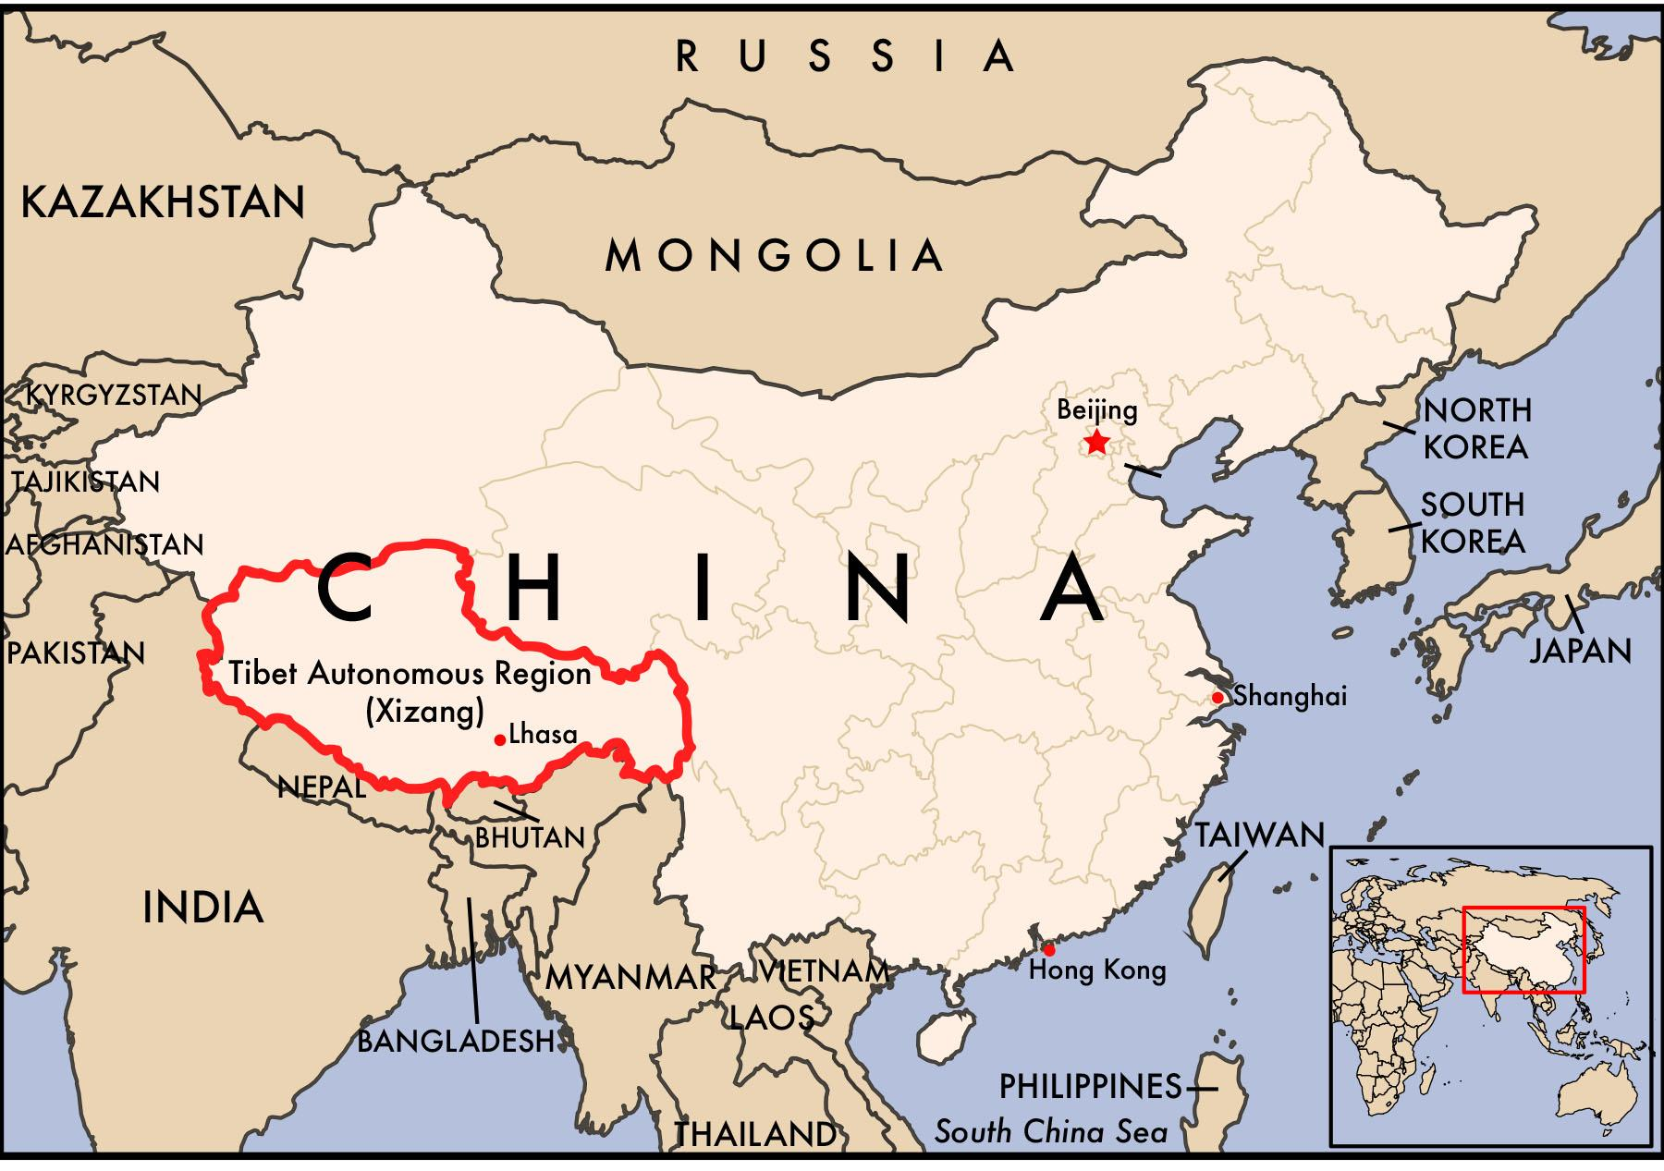

***Note on Disturbing Content***

*This reading contains content that may be upsetting for readers. It describes physical and psychological violence, and might be particularly intense for students with a personal connection to the topic. It is important to be sensitive to your classmates and the ways in which this might be a difficult topic to study.*

Tibet lies to the north of the Himalayan Mountains in what is today southwestern China. Starting in the late fourteenth century Tibetan dynasties enjoyed autonomy, sometimes under agreements with the neighboring states of Mongolia, Nepal, and China. Beginning in the early 1600s a series of Dalai Lamas assumed leadership of Tibet. The philosophies of the Gelug school of Buddhism lay the foundation for government and society.

In 1950, Chinese communist troops entered Tibet and took control. Initially, China did not make social reforms in Tibet. The communist system quickly dismantled other elements of Tibetan government, however, such as by instituting land reform and creating secular (non-religious) schools.

After a rebellion in 1958, Chinese military forces killed and imprisoned hundreds of thousands of Tibetans. The Dalai Lama fled to exile in India, and communist Chinese officials took power. Thousands of monasteries, temples, and other Tibetan architecture were also destroyed. A 1962 report from a Tibetan Buddhist leader chronicled extensive oppression, such as arbitrary arrest and imprisonment, forced abortions, starvation, and the persecution of people openly practicing Buddhism.

Since the 1980s, China’s policies have been aimed at promoting the migration of thousands of ethnic Chinese to Tibet. As a result, Tibetans are now a minority in the region. Since 2001, the Chinese government has focussed its policy in Tibet on rapid economic development and strict control of dissidents. The Chinese government has launched a number of “Strike Hard” campaigns that it claims are aimed at reducing crime in the region. The government has arrested thousands of Tibetans and killed hundreds of others for engaging in “separatist” activities. The Chinese government believes the Dalai Lama seeks independence for Tibet from China, whereas the Dalai Lama claims only to seek more autonomy from the central government. Since 2009, at least 159 Tibetans have set themselves on fire in protest of China’s religious, cultural, and political repression in Tibet.

**Questions**

1. Are China’s actions in Tibet a genocide? Give at least two reasons from the text to support your view.

2. What standards from Article II of the Genocide Convention apply to determine if this event was a genocide?

3. What additional information would you like to have about Tibet?